 | 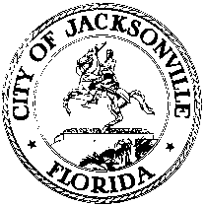
 | OFFICE OF THE CITY COUNCIL
ANNA LOPEZ BROSCHE  PRESIDENT  JACKSONVILLE CITY COUNCIL  OFFICE (904) 630-1452 |  | SUITE 425, CITY HALL  117 WEST DUVAL STREET  JACKSONVILLE, FLORIDA  32202
TASK FORCE ON OPEN GOVERNMENT
AGENDA
May 24, 2018
Lynwood Roberts Room
1:00 pm

Introductions

Public Access to Government
Brian Hughes-Mayor’s Office Chief of Staff (tentative)

Presentation on Technology and Municipal Government
Greg Bugbee- Chief Technology Officer Novus Insight, Inc.

Closing Comments
Discussion and Planning

Public Comment

Chairs: Hank Coxe and Dr. Sherry Magill
Members: Ywana Allen
Rachael Fortune
The Honorable Alberta Hipps
Ron Littlepage
Michael Lockamy
Audrey Moran-Excused
The Honorable Jim Overton
Sabeen Perwaiz
Cleve Warren

The next Task Force Meeting will be Thursday, May 29, 2018 at 1:00 pm
in the Lynwood Roberts 117 West Duval Street, 1st Floor

